Section I
Total Marks (75)

Part A
Total marks (15)
Attempt Questions 1-15
Allow about 30 minutes for this part

Use the multiple choice answer sheet.
Select the alternative A, B, C or D that best answers the question. Fill in the response square completely.

Sample 2+4= (A) 2 (B) 6 (C) 8 (D)9

A  B  C  D 
If you think you have made a mistake, put a cross through the incorrect answer and fill in the new answer.

A  B  C  D 

If you change your mind and have crossed out what you consider to be the correct answer, then indicate this by writing the word correct and drawing an arrow as follows:

correct

A  B  C  D 

SECTION I
Part A
Multiple Choice

- The extraction of copper from copper(I) sulfide produces sulfur dioxide as a by-product according to the equation:

Cu₂S(s) + O₂(g) → 2 Cu(s) + SO₂(g)

What volume of sulfur dioxide gas will be released at 25⁰C & 101.3 kPa when 2.2 g of
copper (I) sulfide is reacted?

(A) 338 mL
(B) 563 mL
(C) 10 mL
(D) 515 mL

- Which acid below is not naturally occurring?

(A) 2-hydroxypropane-1,2,3-tricarboxylic acid
(B) HCl
(C) HBr
(D) CH₃COOH

- H₂PO₄⁻ is an amphiprotic species.
Which of the following represents the conjugate acid and conjugate base respectively of H₂PO₄⁻?

(A) H₃PO₄ and HPO₄²⁻
(B) PO₄³⁻ and H₃PO₄
(C) H₃PO₄ and HPO₄⁻
(D) HPO₄²⁻ and H₃PO₄

- If equal volumes of the following aqueous solutions were mixed, which one would have the highest pH?

(A) 1 mol L⁻¹ NaOH + 1 mol L⁻¹ CH₃COOH
(B) 1 mol L⁻¹ NH₃ + 1 mol L⁻¹ H₂SO₄
(C) 1 mol L⁻¹ H₂SO₄ + 1 mol L⁻¹ Ba(OH)₂
(D) 1 mol L⁻¹ KOH + 1 mol L⁻¹ HCl

- 25 mL of a solution of H₂SO₄ that has a pH of 3 is pipetted into a 250 mL volumetric flask and distilled water added up to 250 mL. What is the pH of the diluted solution?

(A) 0.5
(B) 4.5
(C) 4
(D) 5

- In the Haber process , which of the following conditions would result in an industrially acceptable method of increasing the yield of ammonia?

(A) increasing the temperature of the reaction chamber
(B) channelling the ammonia to a cooling chamber
(C) increasing the amount of N₂(g)
(D) increasing the amount of H₂(g)

- In the production of ammonia using the Haber process, which of the following statements is incorrect?

(A) At equilibrium, the yield is higher when the temperature is lower.
(B) Before reaching equilibrium, the rate is higher at a higher temperature.
(C) The rate of the reaction is lower at a higher temperature because the reaction is exothermic.
(D) At equilibrium, the yield is lower at a lower pressure.

- In a water treatment plant, the monitoring system for the quantity of the flocculant added to the water system malfunctioned with less than the recommended amount being added to the water.
What would be the effect of this on the water quality?

(A) an unusually high bacterial count
(B) a high value of TDS (Total Dissolved Solids)
(C) a water supply with a pH between 8 and 9
(D) a water supply of high turbidity

- Which of the following pairs of compounds are isomers?

(A) 1,2-difluorobutane and 1-fluorobutane
(B) 3-chloro-2-methyl-2-pentene and 1-chloro-1-hexene
(C) 2-bromopropane and 2-bromo-2-propene
(D) 1,2-difluorobutane and 1,2-dichlorobutane

- The concentration of ozone in the troposphere is 0.000002% (v/v). What is this concentration
in parts per million (ppm) ?

(A) 0.0002
(B) 0.002
(C) 0.02
(D) 20

- Which of these displacement reactions can occur spontaneously?

(A) 2 Ag(s) + Cu²⁺ → 2 Ag⁺ + Cu(s)
(B) Pb²⁺ + Sn(s) → Sn²⁺ + Pb(s)
(C) Fe(s) + Mg²⁺ → Fe²⁺ + Mg(s)
(D) 2 Al³⁺ + 3 Ni(s) → 2 Al(s) + 3 Ni²⁺

- The vanadium redox cell currently under development at UNSW acts as
a galvanic cell during the reaction,

V²⁺ + VO₂⁺ + 2 H⁺ → V³⁺ + VO²⁺ + H₂O

Which of the species below is the reductant in this reaction?

(A) V³⁺
(B) VO₂⁺
(C) H⁺
(D) V²⁺

- The reaction shows the production of ethanol from ethene.

C₂H₄ + H₂O C₂H₅OH

Which of the following conditions are necessary for this reaction?

(A) warmth, yeast
(B) heating, refluxing
(C) heating, fractional distillation
(D) heating, pressurising, sulfuric acid catalyst

- Which of the following represent the empirical formulas of polyethene and polyvinyl chloride?

(A) CH₂ and CHCl
(B) CH₂ and C₂H₃Cl
(C) (CH₂-CH₂)n and (CH₂-CHCl)n
(D) (CH₂-CH₂)n and (CH₂-CCl₂)n

- The equation shows the bombardment of U-235 with a neutron which
initiates a fission reaction,

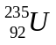 + 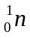 → 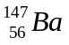 + X + 3

Which of the following correctly identifies species X?

(A) Kr-36
(B) Kr-86
(C) Pa-91
(D) Np-93

Student Number ................................................
Answer Sheet
Section I
Part A
1. A  B  C  D 

2. A  B  C  D 

3. A  B  C  D 

4. A  B  C  D 

5. A  B  C  D 

6. A  B  C  D 

7. A  B  C  D 

8. A  B  C  D 

9. A  B  C  D 

10. A  B  C  D 

11. A  B  C  D 

12. A  B  C  D 

13. A  B  C  D 

14. A  B  C  D 

15. A  B  C  D 

JAMES RUSE AGRICULTURAL HIGH SCHOOL
2002 CHEMISTRY TRIAL HSC EXAM
Section I (continued)

Part B - 60 marks
Attempt Questions 16 -28
Allow about 1 hour and 45 minutes for this part

Answer the questions in the spaces provided
Show all relevant working in questions involving calculations

__________________________________________________________________________
MARKS

Question 16 (3 marks)

A 5.00 mL volume of vinegar was found to weigh 4.50 g. The vinegar was placed into a conical
flask and diluted with 20.0 mL of distilled water. The concentration of acetic acid (ethanoic acid)
in the vinegar was determined by titration with 0.100 mol L⁻¹ sodium hydroxide. At the endpoint,
the titre was 23.3 mL.

(a) Calculate the percentage mass of acetic acid in the original undiluted vinegar. 2

.............................................................................................................................................................
..
..............................................................................................................................................................

..............................................................................................................................................................

..............................................................................................................................................................

..............................................................................................................................................................

(b) What is the concentration (mol L⁻¹) of acetic acid in the undiluted vinegar? 1

..............................................................................................................................................................

..............................................................................................................................................................

..............................................................................................................................................................

Student Number. ..................................................................

MARKS

Question 17 (3 marks)

(a) (i) Explain why ammonium chloride can form an acidic solution in water and
therefore classified as an acidic salt. Use equation(s) in your answer. 1

....................................................................................................................................................

....................................................................................................................................................

.....................................................................................................................................................

.....................................................................................................................................................

(ii) Explain why sodium hydrogen carbonate can form a basic solution in water and
is therefore classified as a basic salt. Use equation(s) in your answer. 1

......................................................................................................................................................

......................................................................................................................................................

......................................................................................................................................................

......................................................................................................................................................

(b) Name a salt which should form a neutral solution in water. 1

..........................................................................................................................................................

MARKS

Question 18 (8 marks)

During your course, you determined the heat of neutralisation of an acid. . Describe the procedure
you followed and justify the appropriateness of the procedure you adopted in order to obtain valid
and reliable results. . 8

................................................................................................................................................................

................................................................................................................................................................

................................................................................................................................................................

................................................................................................................................................................

.................................................................................................................................................................

.................................................................................................................................................................

..................................................................................................................................................................

...................................................................................................................................................................

...................................................................................................................................................................

...................................................................................................................................................................

...................................................................................................................................................................

...................................................................................................................................................................

...................................................................................................................................................................

....................................................................................................................................................................

....................................................................................................................................................................

....................................................................................................................................................................

....................................................................................................................................................................

.....................................................................................................................................................................

.....................................................................................................................................................................

.....................................................................................................................................................................
Student Number. ..........................................

MARKS

Question 19 (4 marks)

Naturally occurring citric acid has the molecular formula C₆H₈O₇. Like all acids, it reacts with carbonate solutions to form carbon dioxide gas. When 1.537 g citric acid was added to a solution containing
excess sodium carbonate, 295 mL carbon dioxide (measured at 25⁰C and 101.3 kPa) was formed.

(a) Write an equation for the reaction of hydrogen ions with carbonate ions. How many moles of
carbon dioxide were formed? 2

...........................................................................................................................................................

............................................................................................................................................................

............................................................................................................................................................

(b) Determine the number of moles of hydrogen ions produced by 1.537 g citric acid. 1

...............................................................................................................................................................

.................................................................................................................................................................

...................................................................................................................................................................

...................................................................................................................................................................

(c) How many replaceable hydrogens (acidic hydrogens) are there in citric acid? Explain your
answer. 1

...............................................................................................................................................................

................................................................................................................................................................

..................................................................................................................................... ..........................

...................................................................................................................................................................

...................................................................................................................................................................
MARKS

Question 20 (2 marks)

Using ethanoic acid and nitric acid in your answer. Draw diagrams to represent:
(a) a concentrated, weak acid solution. (b) a strong, dilute acid solution 2

Make sure you use correct formulas in your diagrams.

concentrated weak acid solution strong, dilute acid solution
Student Number...................................................

MARKS

Question 21 (6 marks)

(a) Describe the procedure you used to quantitatively analyse a manufactured product 4

...............................................................................................................................................................

...............................................................................................................................................................

................................................................................................................................................................

.................................................................................................................................................................

..................................................................................................................................................................

..................................................................................................................................................................

...................................................................................................................................................................

...................................................................................................................................................................

(b) Identify one problem you encountered in the procedure. 1

................................................................................................................................................................

.................................................................................................................................................................

...................................................................................................................................................................

...................................................................................................................................................................

(c) Propose a solution to this problem. 1

................................................................................................................................................................

.................................................................................................................................................................

..................................................................................................................................................................

....................................................................................................................................................................
MARKS
Question 22 (3 marks)

Evaluate the effectiveness of atomic absorption spectrophotometric (AAS) measurements in
pollution control. 3

..................................................................................................................................................................

...................................................................................................................................................................

....................................................................................................................................................................

....................................................................................................................................................................

.....................................................................................................................................................................

......................................................................................................................................................................

.......................................................................................................................................................................

........................................................................................................................................................................

.........................................................................................................................................................................

.........................................................................................................................................................................

.........................................................................................................................................................................

Student Number .....................................................

MARKS

Question 23. (6 marks)

Describe the test for the biochemical oxygen demand (BOD) and evaluate its importance with
respect to the monitoring of the possible eutrophication of waterways. 6

.....................................................................................................................................................................

.....................................................................................................................................................................

.....................................................................................................................................................................

......................................................................................................................................................................

.......................................................................................................................................................................

.......................................................................................................................................................................

.......................................................................................................................................................................

.......................................................................................................................................................................

........................................................................................................................................................................

........................................................................................................................................................................

.........................................................................................................................................................................

.........................................................................................................................................................................

.........................................................................................................................................................................

.........................................................................................................................................................................

..........................................................................................................................................................................

.........................................................................................................................................................................

.........................................................................................................................................................................
MARKS
Question 24 (5 marks)

Discuss the problems associated with the use of CFCs and the steps taken to alleviate these problems. 5

................................................................................................................................................................

................................................................................................................................................................. ..

...................................................................................................................................................................

...................................................................................................................................................................

...................................................................................................................................................................

....................................................................................................................................................................

....................................................................................................................................................................

.....................................................................................................................................................................

......................................................................................................................................................................

......................................................................................................................................................................

.......................................................................................................................................................................

.......................................................................................................................................................................

.......................................................................................................................................................................

........................................................................................................................................................................

.........................................................................................................................................................................

.........................................................................................................................................................................

Student Number..............................................

MARKS

Question 25 (5 marks)

(a) A student prepares 250 mL of a 5% (w/v) glucose solution and adds 1 gram of
yeast. Write a balanced chemical equation for the fermentation which occurs. 1

............................................................................................................................................................

(b) Calculate the mass of ethanol produced. 2

.............................................................................................................................................................

.............................................................................................................................................................

...............................................................................................................................................................
.
................................................................................................................................................................

.................................................................................................................................................................

(c) Describe conditions which promote fermentation. 1

................................................................................................................................................................

................................................................................................................................................................

................................................................................................................................................................

(d) Relate the structure of the ethanol molecule to its use as a solvent. 1

.................................................................................................................................................................

.................................................................................................................................................................

...................................................................................................................................................................

...................................................................................................................................................................
MARKS

Question 26 (6 marks)

Using examples of named polymers, compare and contrast addition polymerisation with
condensation polymerisation. Make reference to the sources of reactants and the processes
used in the manufacture of the reactants. 6

.................................................................................................................................................................

.................................................................................................................................................................

..............................................................................................................................................................

..............................................................................................................................................................

...............................................................................................................................................................

................................................................................................................................................................

.................................................................................................................................................................

.................................................................................................................................................................

.................................................................................................................................................................

.................................................................................................................................................................

..................................................................................................................................................................

....................................................................................................................................................................

....................................................................................................................................................................

.....................................................................................................................................................................

.....................................................................................................................................................................

......................................................................................................................................................................

.......................................................................................................................................................................

.......................................................................................................................................................................

........................................................................................................................................................................
Student Number..................................................

MARKS

Question 27 (4 marks)

(a) Give a reason why some nuclei are unstable. 1

...............................................................................................................................................................

(b) The reaction mechanism for esterification was studied and verified using a tracer. It was
proved that water was formed from an H from the alcohol and an OH from the acid.

H H H O
⎮ ⎮ ⎮ ⎮
H − C − C − O − H H − C − C − O − H
⎮ ⎮ ⎮
H H H

Identify a named radioisotope which could have been used in this research. 1

..................................................................................................................................................................

(c) Cobalt-60 is a multi-purpose commercial radioisotope.
Describe how a non-transuranic isotope like cobalt-60 can be produced in a nuclear reactor and
give an equation to illustrate your answer. 2

.................................................................................................................................................................

..................................................................................................................................................................

..................................................................................................................................................................

..................................................................................................................................................................

Question 28 (5 marks) MARKS

The graph shows the boiling points of the alkane series from methane to octane.
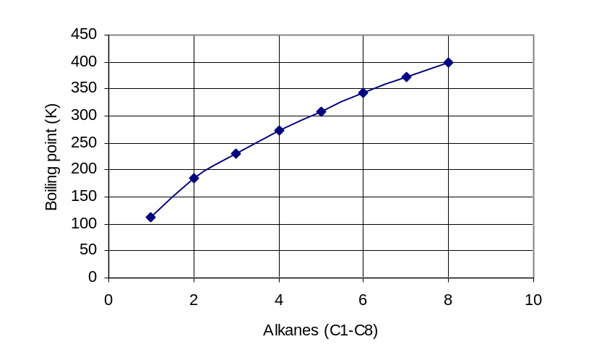(a) Identify which gaseous alkane (plotted on the graph) would be the easiest to liquefy and give
a reason for your answer. 2

...................................................................................................................................................................

.....................................................................................................................................................................

.....................................................................................................................................................................

.....................................................................................................................................................................

(b) Sketch a curve on the graph showing the relative boiling points of the alkanoic acids from
ethanoic acid to hexanoic acid in relation to the corresponding alkanes. 1

(c) Explain the difference in the boiling points of the alkanes versus the alkanoic acids 2

................................................................................................................................................................
.
................................................................................................................................................................

.................................................................................................................................................................

..................................................................................................................................................................

...................................................................................................................................................................

..................................................................................................................................................................

Section II

25 marks

Attempt Question 29
Allow about 45 minutes for this section.

Answer the question in a writing booklet provided
Show all relevant working in questions involving calculations

Question 29. (25 marks) MARKS

(a) Describe the work of Davy and Faraday in increasing the understanding of electron
transfer reactions. 4

(b) Various methods can be used to protect the hulls of ships from corrosion. Explain four different
methods that are used for protection. 8

(c) Describe a passivating metal. 1

(d) (i) Compare the concentrations of gases normally dissolved in the oceans to their concentrations in
the atmosphere. 2

(ii) Explain how the solubilities of these 'soluble' gases vary with ocean depth 2

(e) Three experiments represented in diagrams X, Y, and Z were set up.

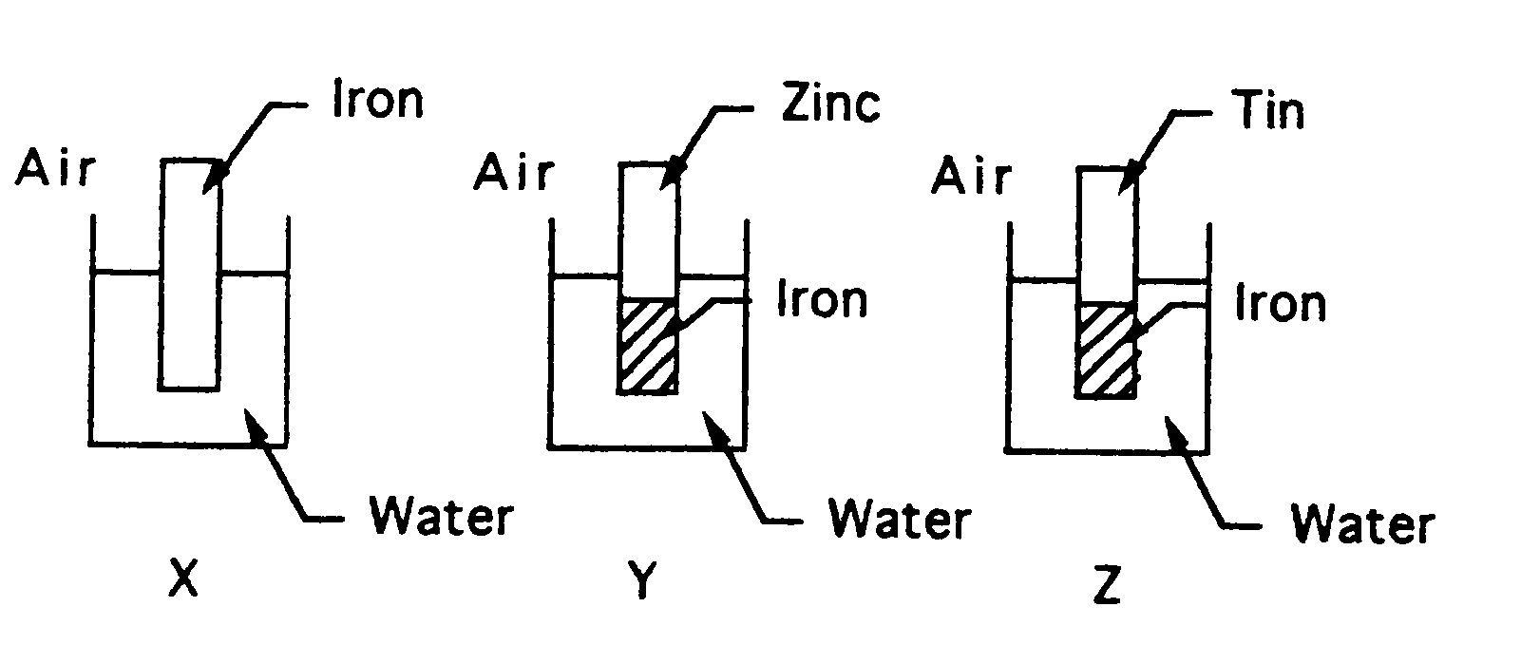

In which of these experiments, all at the same temperature, will the iron corrode the most and
which will corrode the least? Explain your answer. 4

Question 29 continues on page 21.
Please turn over
MARKS

(f) Silver plated objects are obtained in an electrolytic cell in which the object is one electrode. The
other electrode is a block of silver, and silver cyanide solution, AgCN, is the electrolyte. The cell
is illustrated below:
DC power
supply
object to be plated

Silver electrode
AgCN solution

(i) Write a balanced equation to represent the oxidation process. At which
electrode does this occur? 1

(ii) Write a balanced equation to represent the reduction process. At which
electrode does this occur? 1

(g) Consider the electrolysis set-up below:

+
-
DC power
supply
carbon electrodes

K₂SO₄ solution

Describe using half-equations what happens at the anode and at the cathode during electrolysis.

End of Question 29

END OF TEST 

